Action Plan Template:
[Agency Name]
[Incident Type]

Purpose:
An action plan is designed to give a quick snapshot of actions to be taken by an organization to respond to a specific incident. The action plan can be customized to include parts of an emergency response plan/COOP plan to respond to a specific incident type (Weather Impact, Active Shooter, Cyber Response, etc.) or general response (facility impacted, cyber impact).
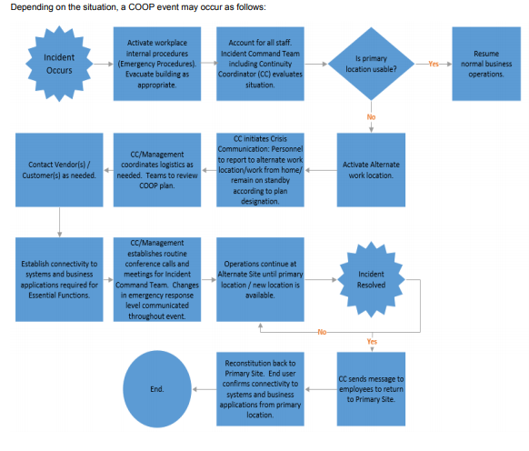

Incident Description: [list description of type of incident] example: An incident has occurred that impacted the William Penn Facility.

Emergency Response Actions: [list initial response steps from your emergency procedure guides] example:

- Pull fire alarm
- Evacuate employees and guests to the primary evacuation location, a safe distance outside of building by following the Fire Evacuation Procedures
- Call 911
- Follow normal fire drill route. Follow alternate route if normal route is too dangerous
- Notify DTI Network Operations Center (NOC) at (302)xxx-xxxx. IT Facilities and Infrastructure Team will contact Facilities Management, Utility providers, and BCDR Team by email to DTI_BCDR_Team@state.de.us.
- Supervisors should account for employees and guests after being evacuated
- Any employee trained in emergency response may temporarily move employees and guests to the parking lot next to the Barrett building. If weather is inclement or building is damaged employees should report to the Webb building for holdover until additional instruction is received to either 1) return to primary work space, 2) go home, or 3) implement Continuity of Operations (COOP). Notify relocation center contacts as outlined in MOU agreement
- No one may reenter the building until the local Fire Department Officer in Charge declares entire building safe
- IT Facilities and Infrastructure Team will report incident to Fire Department

Establish Incident Command Team:
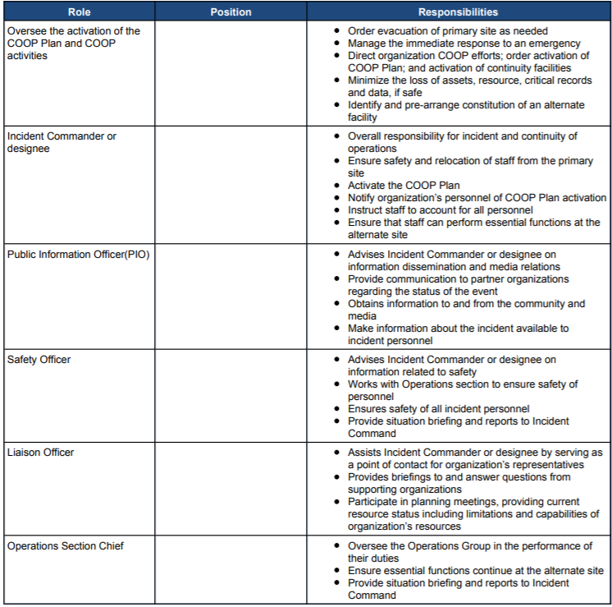
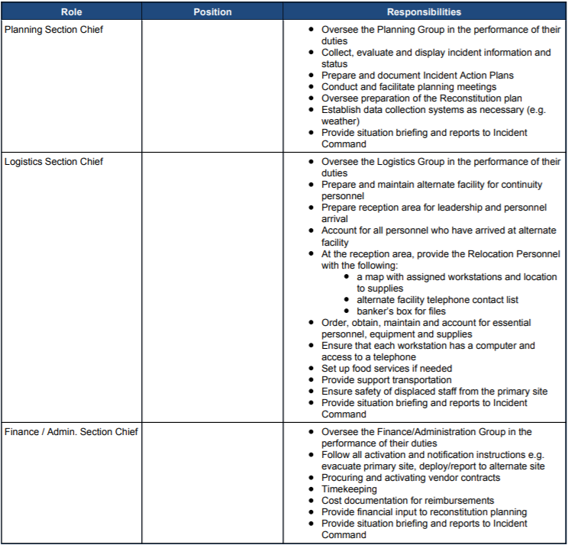
Incident Responders with Task Assignments: [List Critical Teams and tasks from COOP plan]
Example:
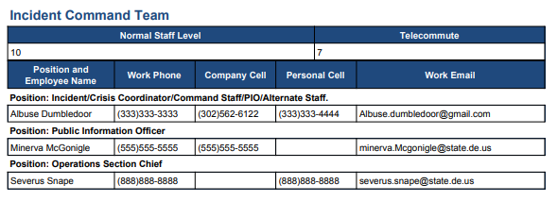
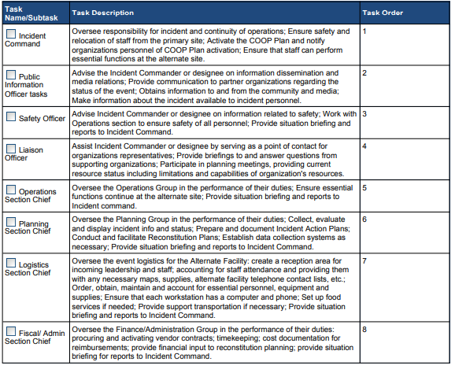
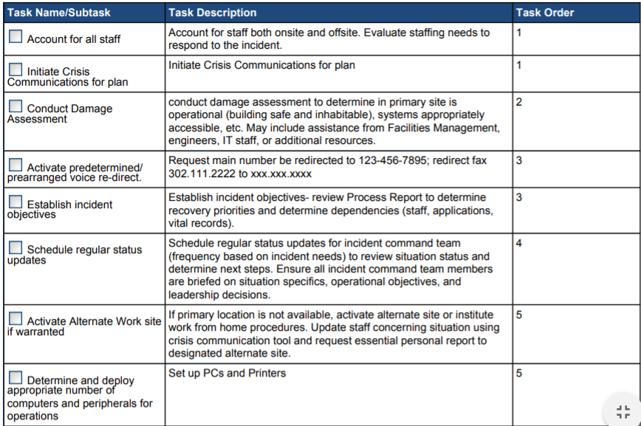
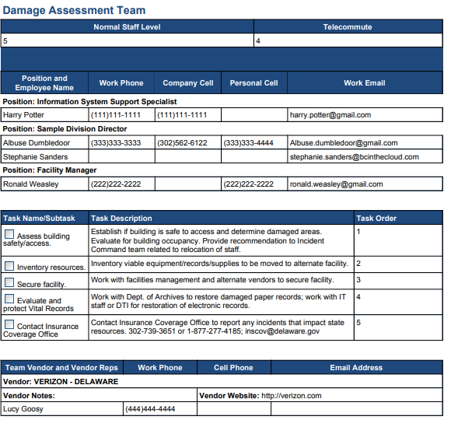
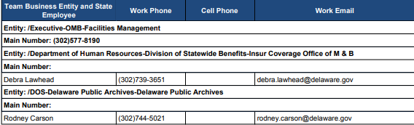

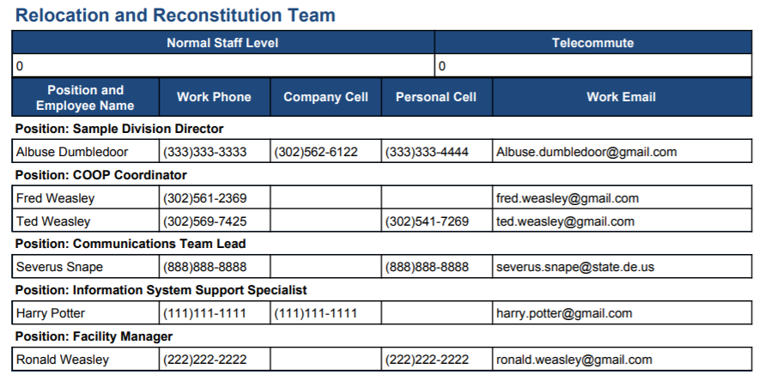
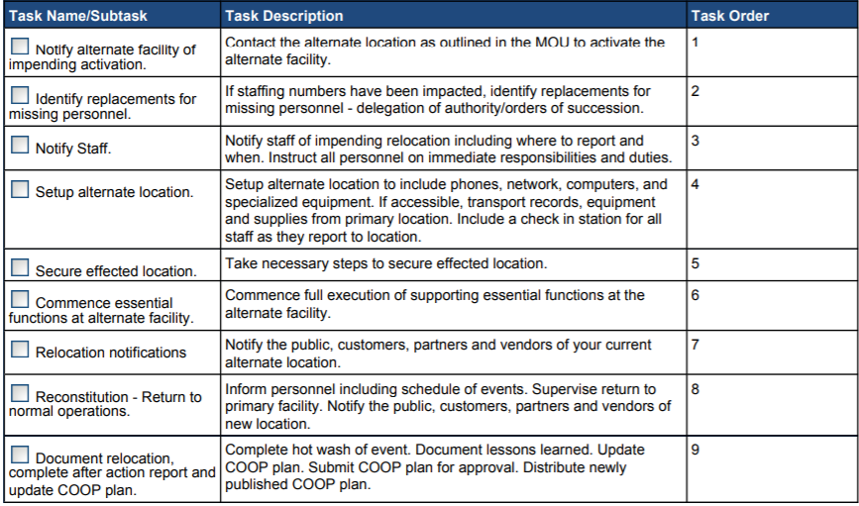

DTI Specific example; Agency should replace all data with organization specific information including locations, contact numbers, and responsible teams.
Plan Team and tasks have been taken from the Sample Plan and should be replaced with Organization specific tasks, contacts, etc.

